**HOSPITAL MANAGEMENT  
SYSTEM**

**SCHEMA DIAGRAM**

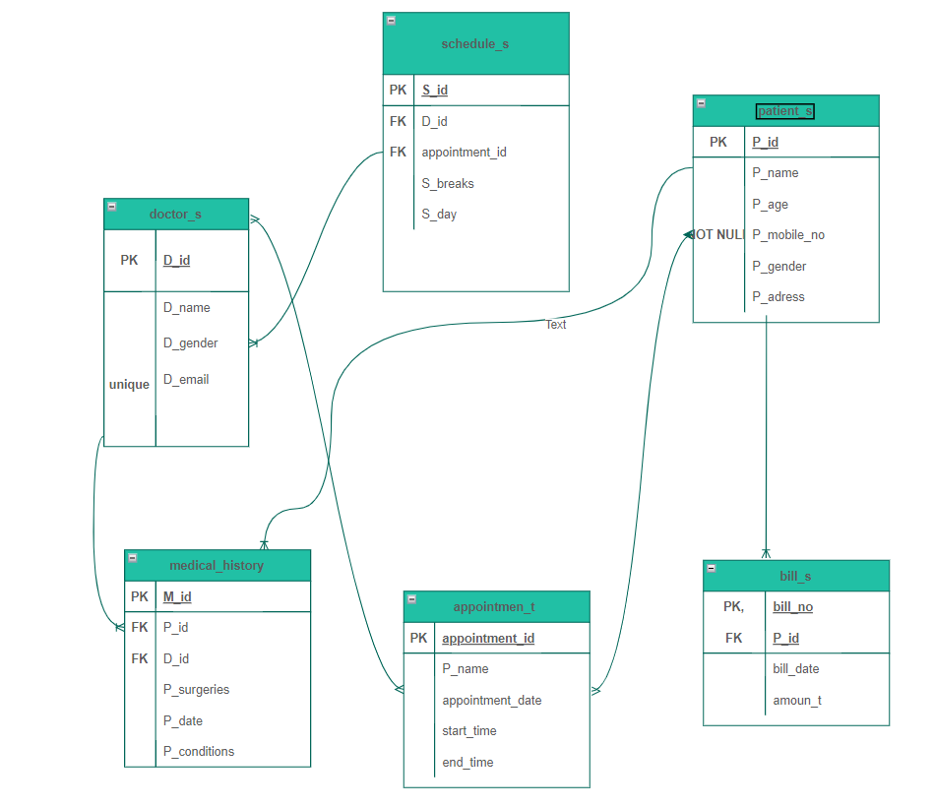

Tables:

1. **doctor_s**

create table doctor_s(D_id varchar(32 )primary key,D_name varchar(22),D_gender varchar(33),D_email varchar(35) unique);

insert into doctor_s values('D001','Dr.Chetna','Female','chetnakaur2@gmail.com');

select * from doctor_s



1. **patient_s**

create table patient_s(P_name varchar(32),P_id varchar(32) primary key, P_age int, P_mobile_no int NOT NULL,P_gender varchar(32),P_adress varchar(32));

insert into patient_s values('Shiv','P001',21,1988765443,'Male','Sector59 phase4 Chandigarh');

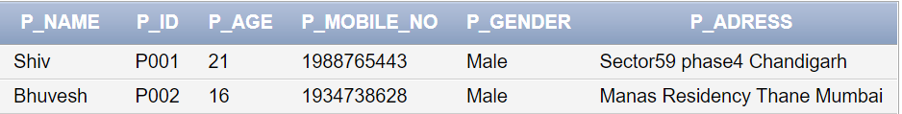

1. **appointmen_t**

create table appointmen_t(p_name varchar(32),appointment_id varchar(23) primary key,appointment_date date,start_time timestamp with local time zone,end_time timestamp with local time zone);

insert into appointmen_t values('shiv','A001',TO_DATE('2022/07/23 ', 'yyyy/mm/dd'), to_date( '2022/07/23 02:00:10','yyyy/mm/dd hh24:mi:ss'),to_date('2022/07/24 03:00:15','yyyy/mm/dd hh24:mi:ss'));

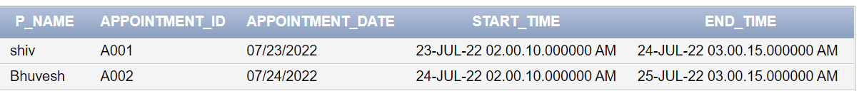

**4.** **medical_history**

create table medical_history(M_id varchar(21) primary key, P_id varchar(21),D_id varchar(21),P_surgeries varchar(31),P_date date,P_conditions varchar(51),

foreign key (P_id) references patient_s(P_id), foreign key (D_id) references Doctor_s(D_id));

insert into medical_history values('M001','P001','D001','Cataract',to_date('07-Jan-2022','dd-mm-YYYY'),'Intermediate');

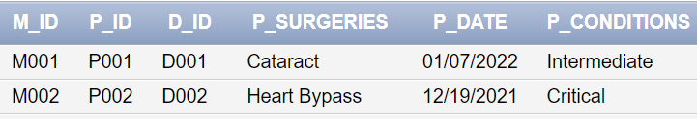

**5.patient_s_VS_appointmen_t**

create table patient_s_VS_appointmen_t(concern varchar(45),symptoms varchar(76),P_id varchar(32),appointment_id varchar(23),foreign key (P_id) references patient_s(P_id),foreign key (appointment_id) references appointmen_t(appointment_id));

insert into patient_s_VS_appointmen_t values('eye problem','headache','P001','A001');

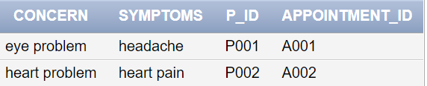

**6.appointmen_t_VS_doctor_s**

create table appointmen_t_VS_doctor_s(diagnose varchar(76),perception varchar (56),appointment_id varchar(23),D_id varchar(21), foreign key (D_id) references Doctor_s(D_id),foreign key (appointment_id) references appointmen_t(appointment_id));

insert into appointmen_t_VS_doctor_s values('examine your lens ','Quixin','A001','D001')

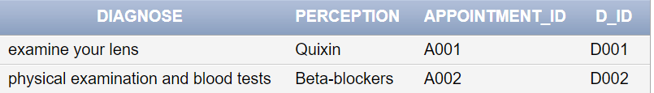

**7.bill_s**

create table bill_s(bill_no varchar(10) primary key, bill_date date, P_id varchar(32),amoun_t int, foreign key (p_id) references patient_s(p_id));

drop table bill_s

insert into bill_s values('B001', to_date('2022/11/29','YYYY/MM/DD'), 'P001',12345);

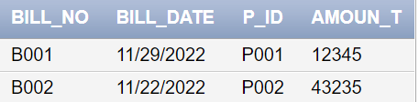

**8.schedule_s**

create table schedule_s(S_id varchar(32) primary key,S_day varchar(42),S_breaks varchar(52),appointment_id varchar(23),D_id varchar(32 ),foreign key (D_id) references Doctor_s(D_id),foreign key (appointment_id) references appointmen_t(appointment_id));

insert into schedule_s values('S001','Monday','1hr','A001','D001')

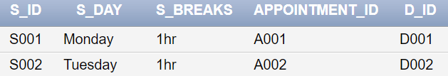

**Queries:**

**1.**SELECT DISTINCT D_id FROM doctor_s ;

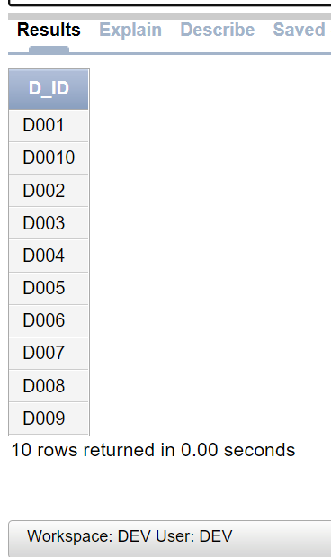

**2.**select D_email from doctor_s WHERE D_name LIKE '%l'

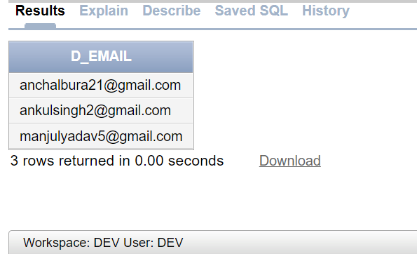

1. SELECT AVG( P_age)

FROM patient_s

WHERE P_gender ='Male'

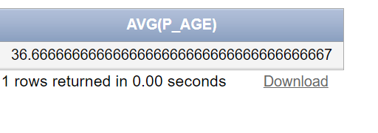

1. SELECT AVG( P_age)

FROM patient_s

WHERE P_gender ='Female'

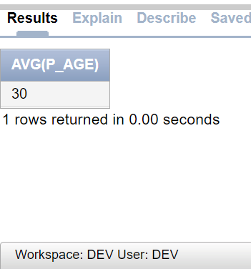

**5.**SELECT COUNT(P_gender)

FROM Patient_s where P_gender='Male';

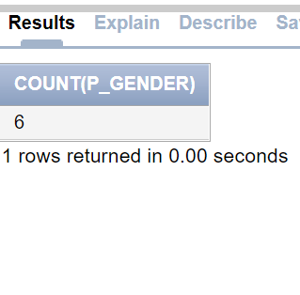

**6.**SELECT COUNT(P_gender)

FROM Patient_s where P_gender='Female';

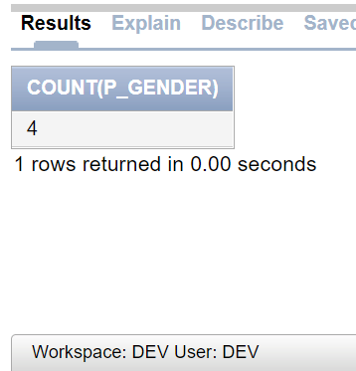

**7.**SELECT COUNT(P_gender)

FROM Patient_s;

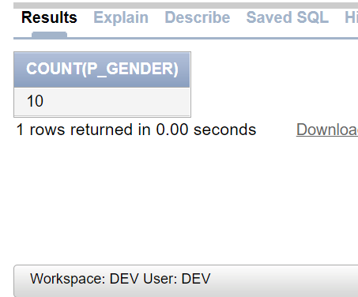

**8.**SELECT * FROM Patient_s

WHERE P_name LIKE 'A%';

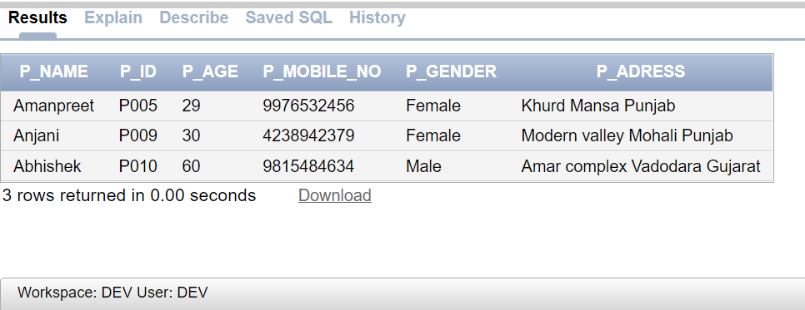

**9.**SELECT * FROM Patient_s

WHERE P_age IN (21,16,25);

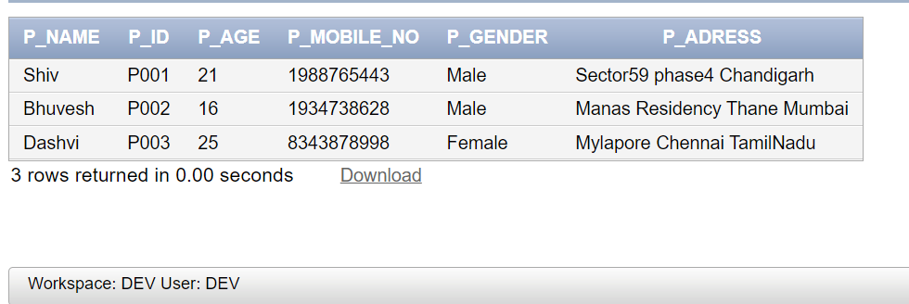

10.SELECT * FROM Patient_s

ORDER BY P_age DESC;

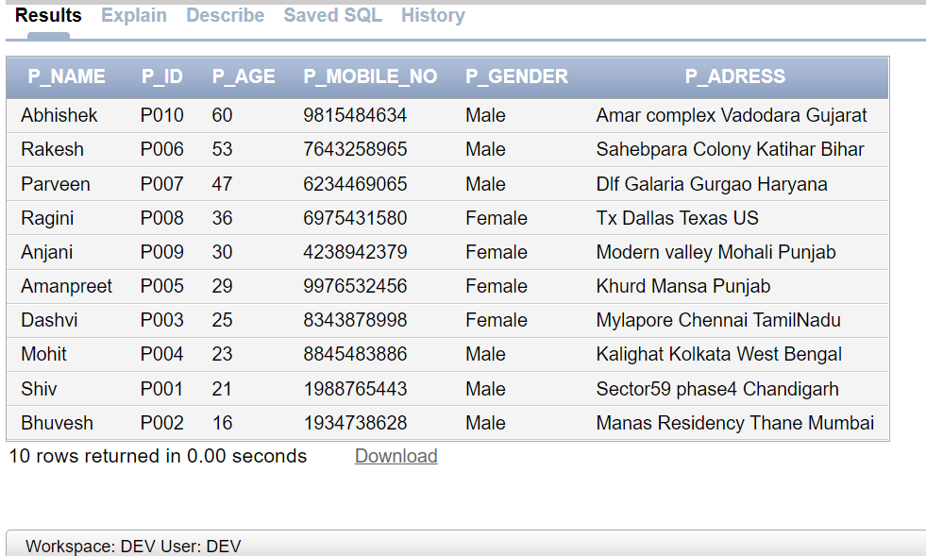

11.SELECT MAX(amoun_t ) AS Largestamount

FROM bill_s ;

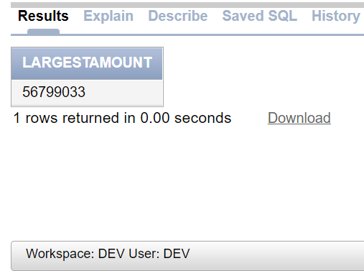

12.SELECT Min(amoun_t ) AS Loweramount

FROM bill_s ;

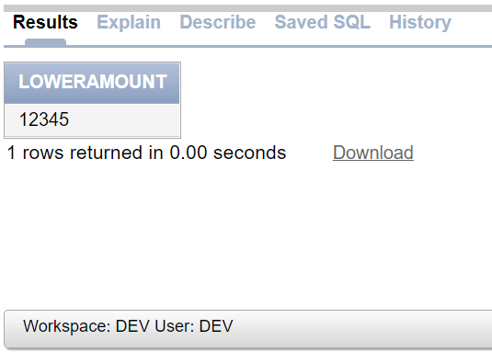

13.SELECT SUM(amoun_t)

FROM bill_s ;

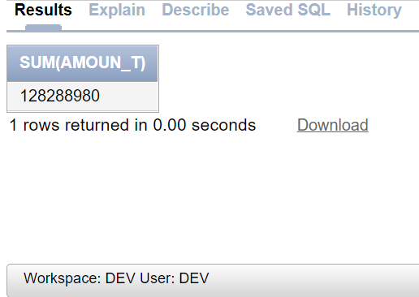

14.Select patient_s.P_name,appointmen_t.appointment_date,schedule_s.S_day from patient_s inner join patient_s_VS_appointmen_t on patient_s.P_id=patient_s_VS_appointmen_t.p_id inner join appointmen_t on patient_s_VS_appointmen_t.appointment_id=appointmen_t.appointment_id inner join schedule_s on appointmen_t.appointment_id=schedule_s.appointment_id ;

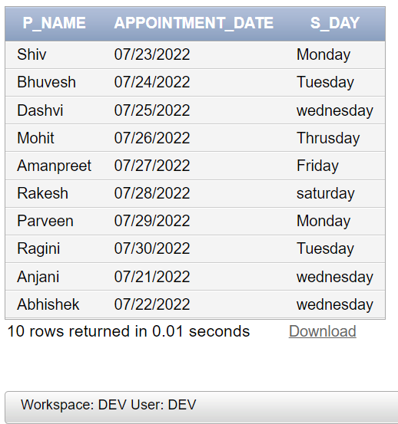

15.select patient_s.P_name,bill_s.amoun_t,bill_s.bill_date from patient_s inner join bill_s on patient_s.P_id=bill_s.P_id;

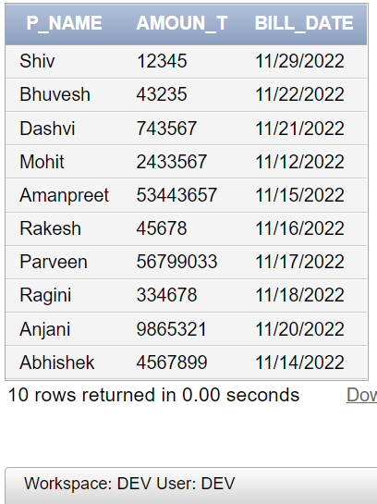

16.select patient_s.P_name,patient_s_VS_appointmen_t.symptoms,appointmen_t.appointment_id, doctor_s.D_name from patient_s inner join patient_s_VS_appointmen_t on patient_s.P_id=patient_s_VS_appointmen_t.p_id inner join appointmen_t on patient_s_VS_appointmen_t.appointment_id=appointmen_t.appointment_id inner join appointmen_t_VS_doctor_s on appointmen_t.appointment_id=appointmen_t_VS_doctor_s.appointment_id inner join doctor_s on appointmen_t_VS_doctor_s.D_id=doctor_s.D_id;

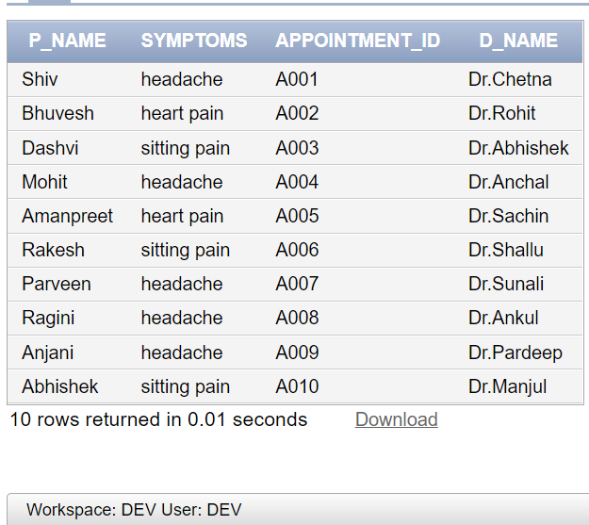

17.select doctor_s.D_id,medical_history.M_id,medical_history.P_surgeries from medical_history inner join doctor_s on doctor_s.D_id=medical_history.D_id;

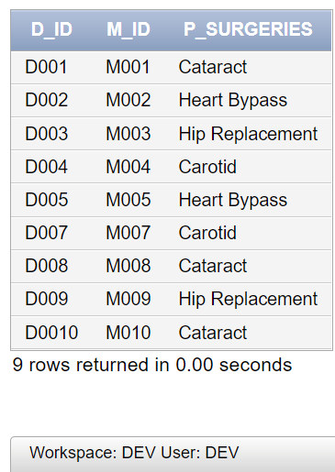

18.select doctor_s.D_id,schedule_s.S_day, doctor_s.D_name from doctor_s inner join schedule_s on doctor_s.D_id=schedule_s.D_id

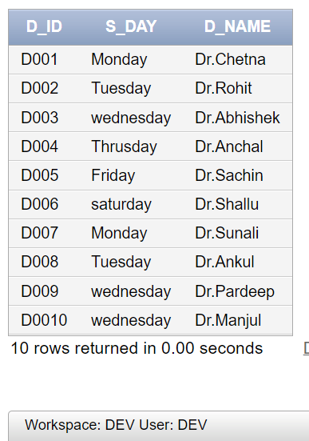

19.select patient_s.P_name,patient_s.P_age,patient_s.P_id,medical_history.M_id,medical_history.P_conditions from patient_s inner join medical_history on

patient_s.P_id=medical_history.P_id ;

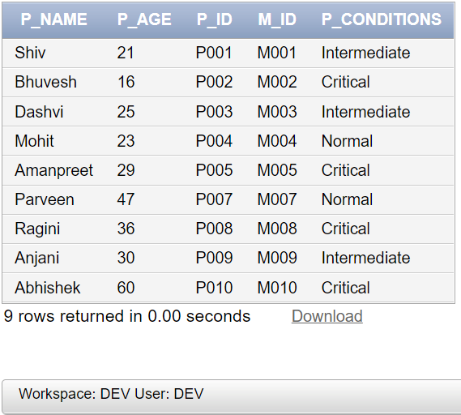

**20.**create view viewss as select patient_s.P_name,bill_s.amoun_t,bill_s.bill_date from patient_s inner join bill_s on patient_s.P_id=bill_s.P_id;

select * from views

